**Gamified Learning Progress Tracker**

**Introduction:**

Let's imagine a world where learning is more like playing a game than dealing with dull grades. Meet the "Gamified Learning Progress Tracker" – a system that turns your academic journey into an exciting adventure! Instead, think of it as an exciting journey, where you face challenges, unlock skills, and level up as you learn.

Forget boring reports and confusing grades! This tracker will be your personal cheerleader, highlighting your strengths, supporting your weaknesses, and showing you exactly how far you've come. Imagine seeing your progress reflected in colorful graphs and charts, feeling the motivation surge with each earned badge, and celebrating milestones with virtual fireworks!

But it's not just about fun and games. This system is powered by real data, giving you and your teachers valuable insights into your learning journey. Think of it as a treasure map revealing your hidden potential, pinpointing areas where you shine, and guiding you towards becoming the ultimate learner.

Teachers, imagine having a secret weapon to understand your students better. With this tracker, you'll unlock individualized data, seeing each student's unique strengths and challenges. This information will become your magic potion, allowing you to personalize your teaching, provide targeted support, and help every student reach their full potential.

Ready for the journey of making something awesome together? Join the Gamified Learning Progress Tracker and get ready to unlock a world of learning, excitement, and personalized growth! Remember, this is just the beginning of your quest. Stay tuned as we explore further into the features, benefits, and the exciting journey that's waiting for you in this innovative learning experience!

**Problem Statement:**

Have you ever felt like report cards only tell half the story? They might show your grades, but what about the hours you spent studying, the challenges you overcame, or the skills you mastered? Traditional grading often paints a one-dimensional picture, neglecting the diverse learning styles, strengths, and needs of individual students. This can be discouraging, especially for those who learn differently or struggle to fit into a uniform pattern. It can also leave both students and teachers in the dark about the specific areas where improvement is needed.

Imagine a student who excels in creativity but struggles with memorization. Their grades might not reflect their true potential, leaving them feeling discouraged and their creativity untapped. Or, a teacher might see a dip in class performance but lack the insights to pinpoint the exact skill causing the difficulty. This is where the Student Performance Monitoring System steps in. By focusing on personalized progress and skill development, it aims to bridge this gap and empower both students and teachers.

**Objectives:**

Get ready to embark on a personalized learning journey with exciting features aimed to benefit students, teachers, and parents/guardians alike! Each objective serves as a stepping stone, guiding us towards building a system that empowers everyone involved:

**Students:**

To visualize progress: See your learning journey through interactive charts and graphs, celebrating milestones and tracking achievements.

To unlock skills: Discover your strengths in each subject, like problem-solving, critical thinking, and communication. Identify areas for improvement and watch your skills bloom.

To boost motivation: Gamification elements like points and badges add fun, encouraging healthy competition and motivating you to conquer learning goals.

**Teachers:**

To gain student insights: Access key details about your students, identifying strengths, weaknesses, and areas needing support. Personalize your teaching and unlock each student's potential.

**Parents/Guardians:**

To track child's progress: Easily monitor your child's learning journey, accessing progress reports, skill development, and areas for support. Offer informed encouragement and be their educational partner.

In a nutshell, our goals set the stage for an awesome learning adventure! For students, it's all about seeing progress, unlocking skills, and getting motivated with fun gamification. Teachers get insights to personalize support and unlock each student's potential. Parents and guardians easily track their child's journey, becoming informed cheerleaders. These objectives create a cool, personalized, and fun learning space for everyone. Ready for an epic educational journey? Buckle up for the ride!

**Methodology:**

The methodology is a proper study or analysis of all the methods used in the research. Methodology is a project recipe – it guides us, makes sure we have everything we need, and ensures we cook up something amazing in the end. This section explains the research design and methods will be used to complete our research, and why we chose that approach.

**Why we should write methodology?**

It's like sharing the steps of our project so that if someone else wants to do a similar project, they can follow our guide and see how their results match up with ours. It's a bit like giving them a map to explore the same territory we did and compare what they find.

**Requirement Identification:**

Requirement identification is like figuring out exactly what we need for our project. It is like making a checklist before a journey. First, we check what's in our backpack (study of the existing system). Then, we ask everyone involved what we will need to bring (requirement collection). It's all about understanding what we have and making a list of what we need for a successful adventure.

**Study of the existing system:**

Examining existing systems also known as light-weight system analysis is like checking out what others have already built-in same field. We look at their features, strengths, and weaknesses to learn from them and avoid repeating mistakes. It's like standing on the shoulders of giants to see further and build something even better. Here are a few things we do in this study:

**Reviewing Documentations:**

We take a close look at documents such as proposals, project reports, and diagrams related to the existing system. It's like reading through a book to understand the story and details.

**Reading Articles:**

We dive into articles about the existing system. Think of it as exploring chapters of a book to gain extra insights, data, or opinions from experts.

**Technology Assessment:**

We evaluate the technologies used in the existing system. Imagine it like inspecting the tools in a workshop to make sure they're up to the task.

**Expert Consultation:**

We seek advice from teachers and friends who are knowledgeable in the field. It's like getting insights from experienced guides on our journey.

**Observation:**

We pay close attention to how the existing system naturally operates. Observations can reveal details that might not be obvious in documents, giving us valuable insights into the system's day-to-day workings.

Here the key question is- what all problems exist in the existing system? What must be done to solve the problem? The commonly used tools in the system are Data Flow Diagram, interviews, etc.

**Some drawbacks in existing or older systems include:**

* Unfriendly user interface and experience (UI/UX)
* Boring and unappealing interface design
* Less secure, exposing potential vulnerabilities
* Sluggish performance and slow response times

These are common issues that we aim to address and improve upon in our study of the existing system. We will implement improvements such as:

* A more user-friendly and visually appealing UI/UX for a better overall experience.
* Interfaces designed to be engaging and interesting, departing from the dull and monotonous layouts.
* Enhanced security measures to ensure a robust and protected system.
* Optimal speed and responsiveness, providing a faster and more efficient user experience.

These enhancements are aimed towards creating a system that not only corrects the problems observed in older systems but also offers a more enjoyable, secure, and efficient.

**Requirement Collection:**

It is a process of collecting information required for a proper system. We follow the below mentioned points to collect requirements:

**Gather user feedback through methods like:**

* Interviews and discussions with students, teachers, parents/guardians.
* Online articles and reports.
* Online group chats.

**Analyze collected data to identify:**

* User needs and desired functionalities.
* Pain points and areas for improvement.
* Prioritize requirements based on importance and feasibility.

**Feasibility study:**

Feasibility refers to the practicality or possibility of a proposed plan, project, or system being successful and effective. A feasibility study is like checking if an idea makes sense and is do-able before diving into it. It's a thorough examination to ensure that a proposed project is realistic, achievable, and economically viable. It involves examining various aspects, including technical, operational, and economic considerations, to determine whether the proposed is feasible and worth pursuing or not.

**Technical Feasibility:**

Examines whether the proposed project can be successfully implemented from a technological perspective.

As I have existing knowledge of HTML, CSS, JavaScript, PHP, and SQL, which provide a solid foundation for this project completion. So, this project is technically viable.

The essential questions that help in testing the operational feasibility of a system include the following:

* Is the proposed system technically achievable with our current knowledge and skills?
* Does the system integrate smoothly with existing technologies and infrastructure?
* Can the technical requirements be met within the proposed budget and timeframe?
* Are there potential challenges in adopting new technologies for the system?
* Is the development team capable of handling any technical issues that may arise during implementation?

**Challenges in Technical Feasibility:**

* **Integration Hurdles:**

Difficulty in smoothly connecting the backend and frontend components of the system.

* **Dependency on Core Code:**

Inability to utilize frameworks or libraries, necessitating reliance on fundamental, core coding practices.

* **Limited Technological Support:**

Facing challenges when advanced technical support or tools are unavailable.

**Solutions:**

* Focus on core functionalities initially, adding advanced features later.
* Making the system simple.
* Guidance from teachers.
* Prioritize secure coding practices and user data protection.

Conclusion: With careful planning and guidance from teachers, the project seems technically feasible. That’s why and how my system is technically feasible.

**Operational Feasibility:**

Operational feasibility evaluates the practicality of implementing the proposed project in terms of day-to-day operations.

The essential questions that help in testing the operational feasibility of a system include the following:

* Will the new system seamlessly fit into our day-to-day operations?
* Is the system user-friendly for both students and teachers?
* Does the implementation require extensive training, especially for non-IT users?
* Can the system be easily maintained, and are there effective data management procedures?
* Will the new system contribute to cost-effective information services for the business?

**Challenges:**

* Figuring out how to manage and analyze data effectively.
* Keeping the system working well and fixing any technical problems that come up.

**Solutions:**

* Conduct usability testing with target users throughout development.
* Design clear interfaces and provide user guides.
* Plan for regular maintenance and updates.

Conclusion: Careful design, user testing, and maintenance can keep operational challenges manageable. That’s why and how my system is operationally feasible.

**Economic Feasibility:**

* Will the project bring more benefits than it costs to implement?
* Can we clearly see how the new system will save time, resources, or improve services?
* Is the expected gain from the project worth the investment we're making?
* How does the project contribute to the college's overall financial well-being?
* Have we thought about when we might start seeing returns on our investment, and how long that might take?
* ROI = (Total Costs/Net Benefits​) ×100
* Are the initial costs and ongoing expenses within the allocated budget?
* Will the economic benefits outweigh the costs over the long term?

**Challenges:**

* Difficulty in accurately estimating the monetary benefits the system will bring.
* Unforeseen expenses arising during the project lifecycle.
* Potential need for additional resources (hosting, domain name) depending on features.

**Solutions:**

* Implement strict budget control, prioritize essential features, and openly communicate with stakeholders about constraints.
* Engage with stakeholders, industry experts, and potential users to gather diverse perspectives for risk management.
* Explore free hosting options or low-cost solutions if needed.
* Manage time effectively and consider seeking support from teachers or online communities.

Conclusion: With focused resource management and prioritizing free or low-cost options, economic feasibility is achievable.

**Overall Conclusion:**

Based on my technical skills, planned features, and resource management approach, the project seems feasible in all three areas.

**High level design of the system:**

High-Level Design is a phase in the system development life cycle that outlines the overall structure and architecture of a system at a broad level. It provides a conceptual framework, focusing on major components, their interactions, and key functionalities.

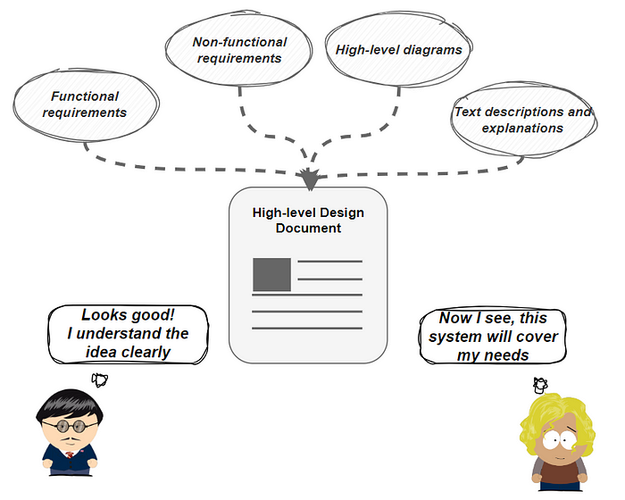High-Level Design Document is a comprehensive document that captures the details of the high-level design phase. It includes architectural diagrams, module descriptions, data flow diagrams, interface details, key functionalities, technological choices, security protocols, performance considerations, error handling, and user interaction overviews.

### Fig: HLDD

**Limitations that solution architects are expected to take into account when designing the High-Level Design:**

* **Gathering Requirements**:

The requirements maybe functional or non-functional.

**Functional requirement:**

These define what the system must do in terms of specific features and functionalities. They answer the question "What should the system do?". Here are some examples:

* Track student progress through various learning activities.
* Allow teachers to assign and monitor tasks.
* Offer gamified UI design.
* Display progress reports for students.

**Non-Functional Requirements:**

These describe how the system should perform and the qualities it should possess. They answer the question "How should the system work?". Here are some examples:

* Our system will load quickly.
* This system can handle a greater number of users.
* This system is completely reliable and error less.
* Users’ data login data like id and password will be encrypted.
* This system is user-friendly for all students, teachers, and parents/guardians.
* It is easy to make any changes or any updated.

**System Flow Chart:**

A flowchart is a graphical representation of a process. It's a diagram that illustrates the workflow required to complete a task or a set of tasks with the help of symbols, lines and shapes.

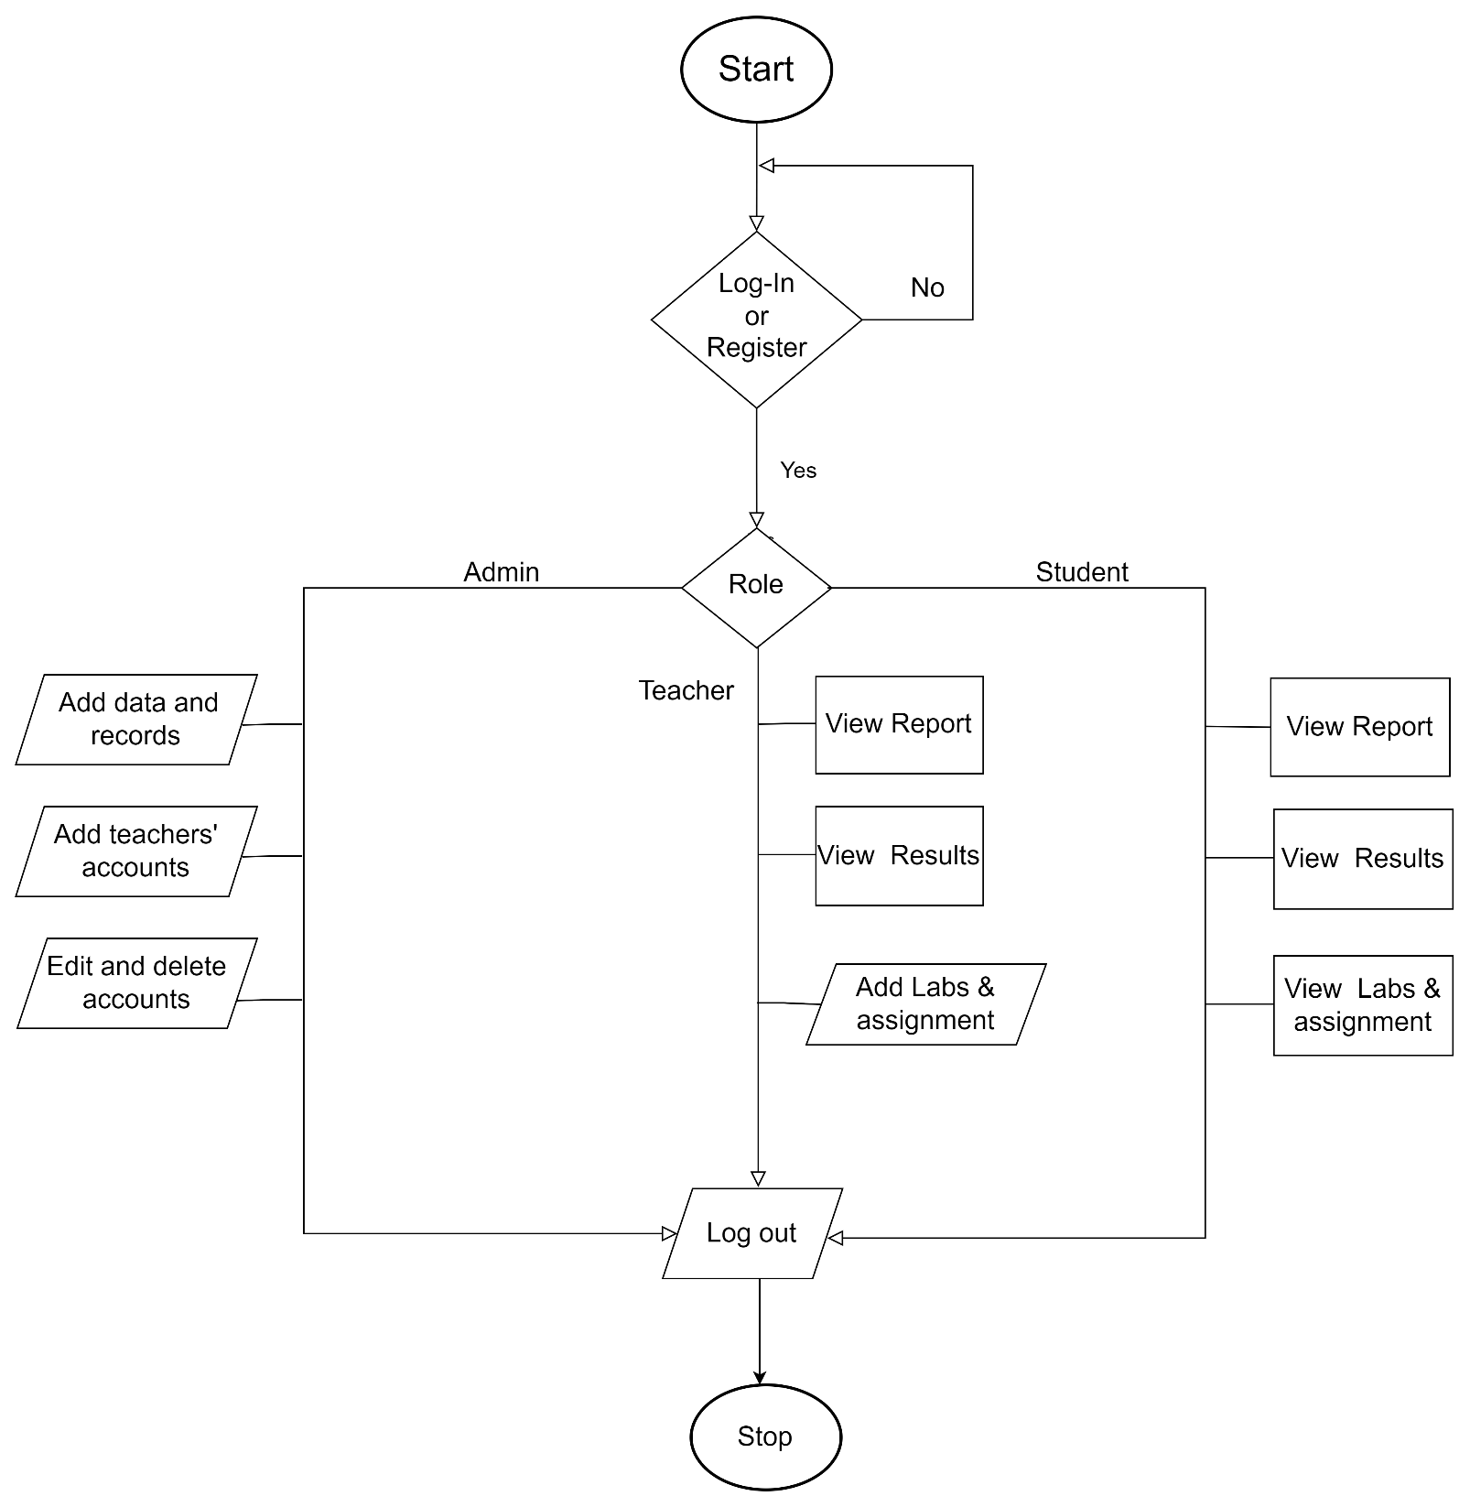

### 

### Fig: Flow chart of this system